Helping Your Child with Reading

– Some Questions to ask about a book

Here are some questions that may help you to support your children’s reading and enjoyment of the stories that they choose. It is not expected that you ask every question, every time they read a book to you! However, by choosing 2 or 3 of the questions to ask your child before, during and after the reading of their book, it will support their developing comprehension of what they read and ultimately, their enjoyment of the books that they choose.
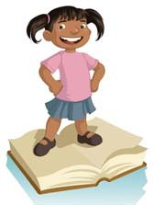
Whilst the questions and ideas listed below will help to develop and support your child’s reading in Key Stage 1, they can also be adapted to allow you to support your child as they continue to develop in their reading and enter Key Stage 2.
They can also be adapted to any text that your child is reading (eg. comics, newspapers, leaflets, information on signs (eg. At the zoo), etc)
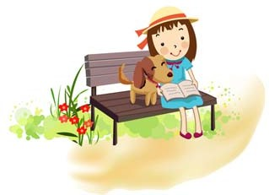

Asking Questions about a book…
Choosing a book:
- Why did you choose this book?
- Did you like the picture on the front?
- Have you read other books by this author?
- Did you choose it because it is about … (eg. Trains, cats, etc)
- What could this book be about?
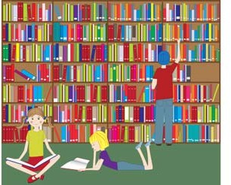

Before reading the book:
- Can you point to the title? or What is this? (pointing to the title)
- What do you think this story will be about? What might happen in the story?
- What do we call the writing on the back of the book? (Blurb) or What does the blurb tell us?
- Talk about the different parts of the book (eg. Front cover, back cover, title, author, illustrator, blurb, ISBN number, bar code, publisher marks)
- If it is an information book ask them where you will find out about something specific (ie. can the child use the Contents page or Index to locate information?)
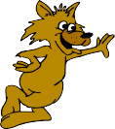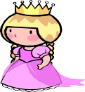

During the reading of the book:
- Tell me what is happening in the pictures?
- What has happened so far? Is it what you expected to happen?
- What might happen next? How do you think the story might end?
- What sort of character is….? Is he/she friendly/ mean/ nice…?
- Ask children about events in the story: How would you feel if you had been that character? Has anything like that happened to you? Would you like that to happen to you?
- If reading an information book: What facts have you read? Have you learnt anything new? What does this page tell you about? Is there anything that interests you on this page? Where would you go to find information about….?



At the end of the book:
- What was their favourite part? Why?
- What was the most interesting/ exciting part of the book? Can you find it?
- What sort of character is….?
- Why did that character do … (give a situation/ event from the story)?
- What happened in the story?
- Are there any words or phrases that you enjoyed?
- Did the pictures help you to understand the story better?

- Would you still read this book if it did not have pictures? Why?
- Are there any parts of the book that are repeated? Why do you think that the author did that?
- Who are the main characters in the story? What character would you like to be?
- Why are some words written in capital letters? Italics? Bold print? Different colour?
- Do you think this book has helped you to understand… Better?
- Would you like to read another story by this author or illustrator?
- Have you read any other books like this one? Is it happy/ sad/ scary/ exciting? Why do you think this?
- Does this book remind you of any other stories, or TV programmes/ DVDs?
- Does this story remind you of anything that has happened to you?
- Tell me about some other books that you have read recently.
- Did you like this book? Why? (Encourage children to develop their opinion about books by encouraging them to explain their reasons)
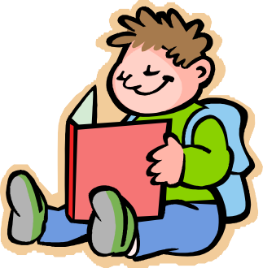

Some key words to use when discussing books with your child:

Story Book Character Setting Plot Author Illustrator Title Contents Index Glossary Headings
Sub-headings Blurb Beginning Middle
End Fiction
Non-fiction
Information Page Bold Italic
Under-lined Pictures/ illustrations
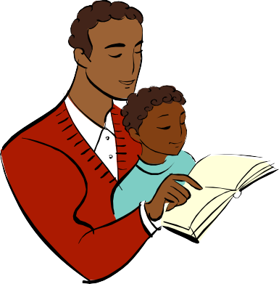
Predict Front cover Back cover Publisher

