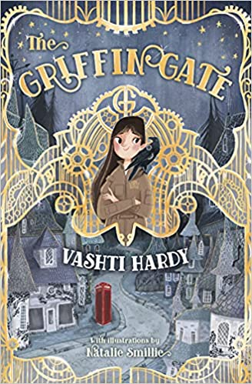
Year 4 book recommendations
‘How to train your Dragon’ by Cressida Cowell
‘The land of Roar’ by Jenny McLachlan
‘Earth shattering events’ by Sophie Williams
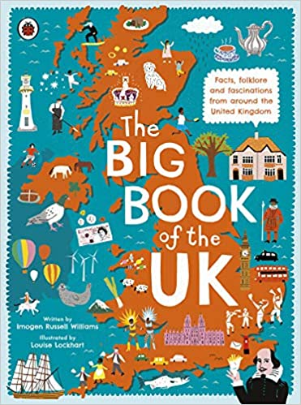
‘Real-life mysteries’ by Susan Martineau
‘Race to the frozen north’ by Katherine Johnson
‘The big book of the UK’ by Imogen Russell Williams
‘The butterfly lion’ by Michael Morpurgo
‘James and the giant peach’ by Roald Dahl
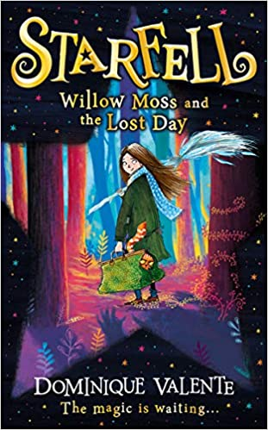
‘The Griffin gate’ by Vashti Hardy
‘A street through time’ by Steve Noon
‘Starfell: Willow Moss and the lost day’ by Dominque Valente

