Some great spelling strategies

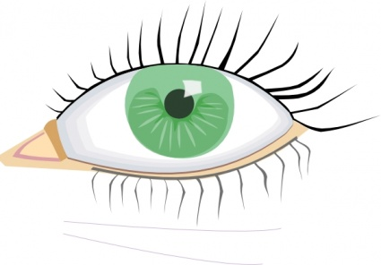 | 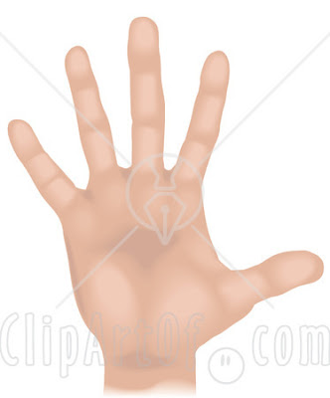 | 
Look | Cover | Write | Check

SKYWRITING
Spell the words in the air with your finger!


RAINBOW WRITING!
Write each letter of the word in different col colours

question
COLOUR CONSONANT
When you write each word, colour consonants
one colour and vowels another

SHOUT IT OUT!
Spell the words out loud!

STAND AND SIT!
spell the word out loud, standing for consonants and sitting for vowels

CLAP IT!
Clap your hands to each letter as you spell it out loud.

CHANGE THE SIZE!
Write each word using the smallest writing you can, then normal sized, then giant!

JUMPING JACK WORDS
Do a jump for each letter as you spell the word out loud

WHATS THE SHAPE?
draw a line around the word, what shape does it make? If you do this on ActivInspire then you can move the word out of the shape. Children then need to match the words to their shapes

SPELLERCISE!
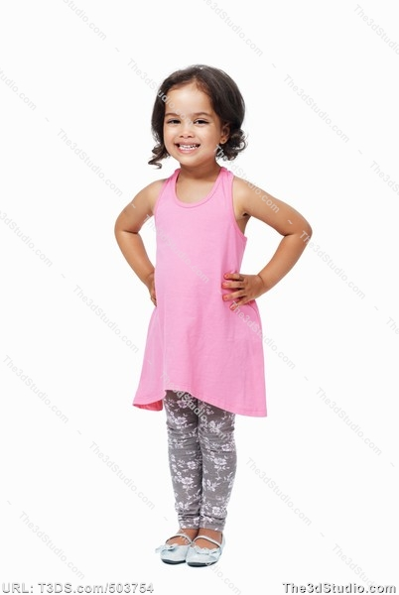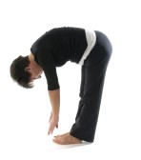
b a g
Raise your hand high for a tall letter,
Put your hands on your waist for a normal
Letter and touch the floor for a letter that
goes below the line

PICTURE
Draw a picture to help you remember the word

MNEMONICS
people – people eat orange peel like elephants

