5th November 2024

Dear Parents and Carers,

New member of the team – school therapy dog in training

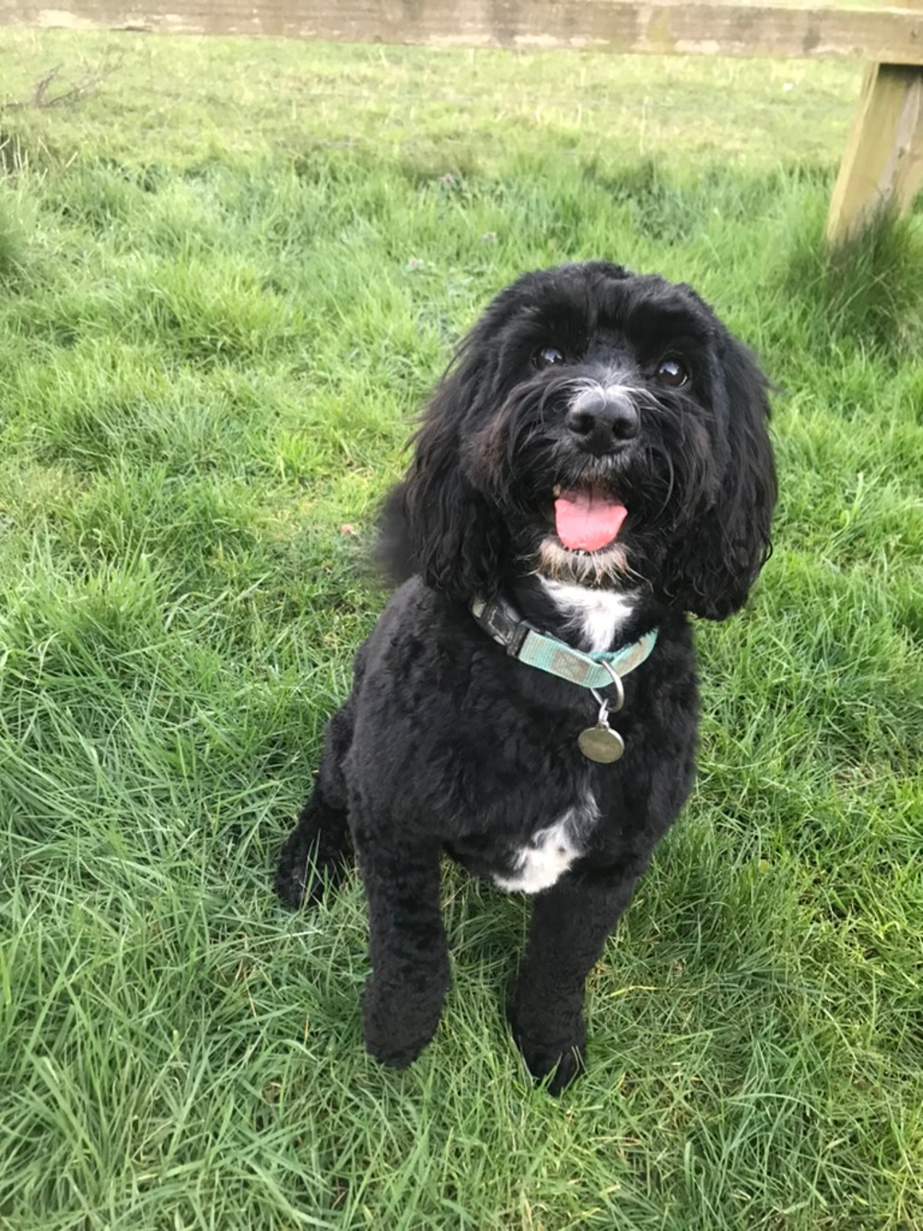
I am delighted to introduce to you a new member of the St Nic’s team. Halle will be joining us in school on a part-time basis and is in training as a PAWS therapy dog. Once settled in school, Halle will support pupil wellbeing and reading.

Research shows that animal assisted education is widely accepted as benefitting children’s well-being, communication and social skills. Studies have shown that the presence of companion animals can improve the well-being of children and lower the rate of anxiety. Dogs are increasingly being used in schools with great success and they are also used in some hospitals, care homes and in counselling as the emotional health benefits they can bring are significant. I believe that this is the right time for us to bring these benefits into our school.

Last year, every class enjoyed a ‘Be Dog Safe’ workshop with The Dogs Trust. The children’s response to this was enormously positive. This term, while Halle settles into her new surroundings and continues her training, we will introduce the children to PAWS dog safety rules and boundaries for interactions with their school therapy dog.

Halle is an energetic, gentle, four-year-old cockerpoo. She makes connections with children easily, in a non-judgemental, undemanding way. She also seems to sense when a snuggle might be needed. Halle is registered with a local vet and has regular checks, plus worming and flea treatments at the appropriate intervals. Her immunisations are kept up to date and a full risk assessment has been completed.

Halle lives in our family home and will be introduced to the school environment and pupils over the next few weeks. She will have a gradual acclimatisation into school life, becoming accustomed to the routines of the day and supported by the PAWS therapy dog programme. Her main place of residence will be Ms Holmes’ office, which is secure and separate from the classrooms. She will be kept on a short lead when she is moving around school and will always be with a member of staff.

Please contact the school office via email if your child is allergic to dogs or you would like Halle to be introduced progressively to your child as they are nervous about dogs. We love to work together with you! Children need not have contact with Halle if they do not wish it, contact will always be invitational. Just let us know.

I hope the children and the school community will gain a lot of enjoyment from having a school therapy dog. During the next few weeks, we will post more information about the PAWS programme on the website and there will be pictures of all Halle gets up to!

If you have any concerns about your child, please do not hesitate to contact me by email via the school office.

With best wishes,

Ms R Holmes
Headteacher

