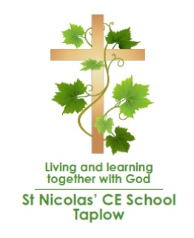
St. Nicolas’ CE Combined School Taplow
Rectory Road, Taplow, Bucks SL6 0ET
Tel: 01628 603759
Email: schooloffice@stnicolastaplow.com
Website: www.stnicolastaplow.com
Headteacher: Ms R Holmes

Y2 Ash Class Curriculum News Spring 2026

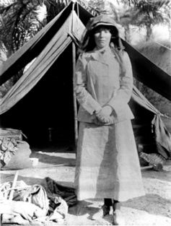
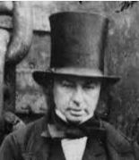
Happy New Year! We hope you had a lovely holiday and a wonderful Christmas. This term we will be beginning a new topic for history called ‘Adventurers and Explorers’ in which we will learn all about some significant individuals including Neil Armstrong, Gertrude Bell and Isambard Kingdom Brunel. We will find out why they are famous, and how they have made a difference to our lives even today. After half term, we will move onto geography and will be learning about our local area. This will include looking at maps and a field study of Taplow.

Break times play an important part in the school day; the children benefit from the chance to stretch their legs and get out in the fresh air, even when there are rain showers. Having a coat in school (named please) is essential, as we will play outside every day.

We will continue to wear PE kit to school on Mondays and Thursday ready for our PE lessons. Please make sure that if your child is wearing footwear with laces, they can tie them themselves.

Essential Information
Monday | All home learning in  Spellings tested  Planners in for checking and books swapped  PE – come to school wearing your PE kit
Tuesday | New home learning and spellings given out
Wednesday
Thursday | Library day  PE – come to school wearing your PE kit
Friday
Every day | Coats, reading books and planners in school
Art and DT
This term we will be doing a range of projects based around the theme of ‘superheroes’, including pop art and printing. In DT, we will look at how to create stable structures.

Reading
Every child will be given 2 reading levelled books and a library book to read with adults at home. Some children will also have 2 RWI books each week. Read each book at least once and ask questions about the text. This will help to develop your child’s accuracy, fluency and comprehension skills and have a long-term positive impact on their chances of success in education.

Spellings
We will have a daily spelling lesson, with a new spelling pattern being introduced each week. Children should practise and learn the words that are sent home so that they are ready for the spelling test each Monday. The English curriculum places a lot of emphasis on spelling, and it is important for later success that your child does not have gaps in their learning from previous years.
Maths
Learn the x2, x5 and x10 tables – including division facts. Know the names of 2D and 3D shapes. Teach your child the value of coins and do simple addition and subtraction with them. Teach your child to recognise 1/3s, 1/4s and 1/2s.

Home learning expectations
We expect home learning to be handed in on time. Please make sure they are presenting their work neatly. If your child has any issues with home learning, please make sure they speak to the teacher about it or contact the teacher yourself so that we are able to help them prior to the completion date.
Water bottles and snacks!
Your child needs a water bottle in school every day. A fruit or vegetable snack for break time will be provided.
What will we be learning this term?

English | Narrative and non-fiction writing
Grammar | Spelling patterns, including adding suffixes, commas and apostrophes, sentence types, past and present tense
Reading | Reading with accuracy and fluency, and developing comprehension skills
Maths | Multiplication and division, statistics, money, length and height, mass capacity and temperature
Science | Materials, The Big Science Event
History/Geography | Explorers and adventurers; Local geography
RE | In what ways is the synagogue important to Jewish people? Salvation: why does Easter matter to Christians?
PSHE | Keeping myself safe; Rights and responsibilities.
Art and DT | Pop art printing; stable structures
Computing | Robot algorithms, data and information: pictograms
PE | Gymnastics, hit, run, catch, netball and football themed games

Please don’t hesitate to contact us if you have anything you wish to discuss. You can catch us on the gate or for a longer appointment request a meeting before or after school or a telephone call, via the office.

Mrs Anderson (Monday – Thursday) and Mrs Cross (Friday)

