Below are some strategies to use when learning spellings:

FLASHCARDS
Write each word on a piece of card. Regularly hold the card up for the child to read, and then spell. As the child becomes more confident – stop sharing the flashcard before they spell it and just say the word.
This is a good activity to do whilst you are on the train, cooking dinner, waiting for a taxi…

SKYWRITING
Spell the words in the air with your finger!


RAINBOW WRITING!
Write each letter of the word in different col colours

SQUISHY WRITING
Write the words in sand or with plasticine

COLOUR CONSONANT
friendship
When you write each word, colour consonants
one colour and vowels another

SHOUT IT OUT!
Spell each of the letters out loud!

STAND AND SIT!
spell the word out loud, standing for consonants and sitting for vowels

CLAP IT!
Clap your hands to each letter as you spell it out loud.

CHANGE THE SIZE!
Write each word using the smallest writing you can, then normal sized, then giant!

JUMPING JACK WORDS
Do a jump for each letter as you spell the word out loud

LOOK COVER WRITE CHECK
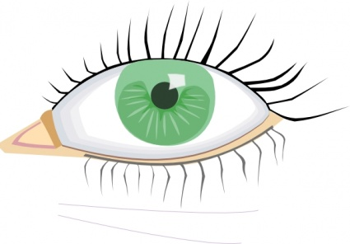 |  | 
Look | Cover | Write | Check

WHATS THE SHAPE?
Draw a line around the word, what shape does it make?
Challenge: draw the shape of the word/s. Can children guess the word for the shape?

SPELLERCISE!
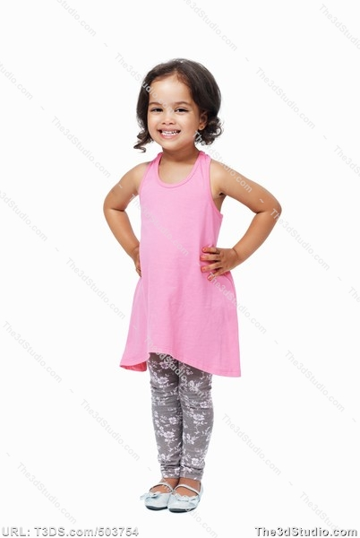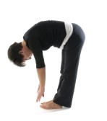
b a g
Raise your hand high for a tall letter,
Put your hands on your waist for a normal
Letter and touch the floor for a letter that
goes below the line

ANAGRAMS
Create anagrams for the words children need to learn

MNEMONICS
people – people eat orange peel like elephants

STICK WRITING
Collect sticks and write the word using the sticks. Great activity when out walking.

